International Conference on Cyber Analytics and Information Retrieval

Organized by
Sister Nivedita University (SNU), India

Technically Sponsored by:
Scientific Innovation Research Group (SIRG), Egypt
Scientific Research Group in Egypt (SRGE), Egypt
CI2S lab, Argentina

Date: 24th – 25th April 2025 (Hybrid Mode)

************** CALL FOR PAPERS **************

SPECIAL SESSION
Special Session Title: Enhancing Cybersecurity and Resilience in Cyber-Physical Systems for Addressing Vulnerabilities and Attack Mitigation Strategies

SESSION ORGANIZERS:

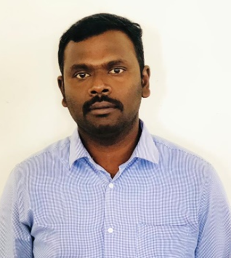 |  | 
Dr Mahaveerakannan R,  Professor  Department of Computer Science and Engineering  SIMATS Engineering,  Saveetha Institute of Medical and Technical Sciences,  Chennai, Tamil Nadu, India.  mahaveerakannanr.sse@saveetha.com | Dr. S. Saraswathi  Professor,  Department of Computer Science and Engineering  SIMATS Engineering,  Saveetha Institute of Medical and Technical Sciences,  Chennai, Tamil Nadu, India.  Saraswathis.sse@saveetha.com | Dr Balamanigandan, R  Professor,  Department of Computer Science and Engineering,  SIMATS Engineering,  Saveetha Institute of Medical and Technical Sciences,  Chennai, Tamil Nadu, India.  balamanigandanr.sse@saveetha.com

SESSION DESCRIPTION:
Cyber-Physical Systems (CPS), which integrate physical processes with computational elements, are increasingly crucial in sectors like transportation, energy, healthcare, and manufacturing. However, the convergence of cyber and physical components exposes CPS to significant cybersecurity threats, where cyber-attacks can directly impact physical operations. These vulnerabilities can lead to catastrophic failures, such as compromised safety in autonomous vehicles, blackouts in smart grids, or industrial disasters in critical infrastructure.

A major research focus is developing advanced attack detection and prevention mechanisms, such as intrusion detection systems (IDS) that can identify malicious activities in real-time, while operating within the resource constraints typical of CPS. Additionally, resilient design strategies are being explored to ensure CPS can continue functioning even under attack. This includes fault-tolerant control algorithms that maintain system stability and reliability in the presence of compromised sensors or actuators. Secure communication protocols are also essential to safeguard data exchanges between system components from unauthorized access or tampering.

RECOMMENDED TOPICS:
Topics to be discussed in this special session include (but are not limited to) the following:

- Cybersecurity in Cyber-Physical Systems
- Resilience and Fault Tolerance in CPS
- Autonomous Systems and CPS
- Edge and Fog Computing for CPS
- CPS for Smart Cities
- Real-Time Systems in CPS
- Human-Cyber-Physical Interaction
- CPS in Healthcare and Medical Systems
- Energy Management and CPS
- Sensor Networks in CPS
- Artificial Intelligence and Machine Learning for CPS
- CPS for Autonomous Industrial Systems (Industry 4.0)
- Distributed Control Systems in CPS
- CPS for Robotics and Automation
- CPS for Transportation and Autonomous Vehicles

PUBLICATION AND SUBMISSION PROCEDURE
The conference aims at carrying out double-blind review process. The papers submitted by the authors will be assessed based on their technical suitability, the scope of work, plagiarism, novelty, clarity, completeness, relevance, significance, and research contribution. The conference proceedings will be published in AIP Web of Science, Scopus series.

NOTE: While submitting the paper in this special session, please specify [Special session title] at the top (above paper title) of the first page of your paper.

* * * * * *

