International Conference on Cyber Analytics and Information Retrieval

Organized by
Sister Nivedita University (SNU), India

Technically Sponsored by:
Scientific Innovation Research Group (SIRG), Egypt
Scientific Research Group in Egypt (SRGE), Egypt
CI2S lab, Argentina

Date: 24th – 25th April 2025 (Hybrid Mode)

************** CALL FOR PAPERS **************

SPECIAL SESSION
Special Session Title

Advancements in AI, ML, VLSI, Signal / Image / Video Processing and Integrated Networks

SESSION ORGANIZERS:

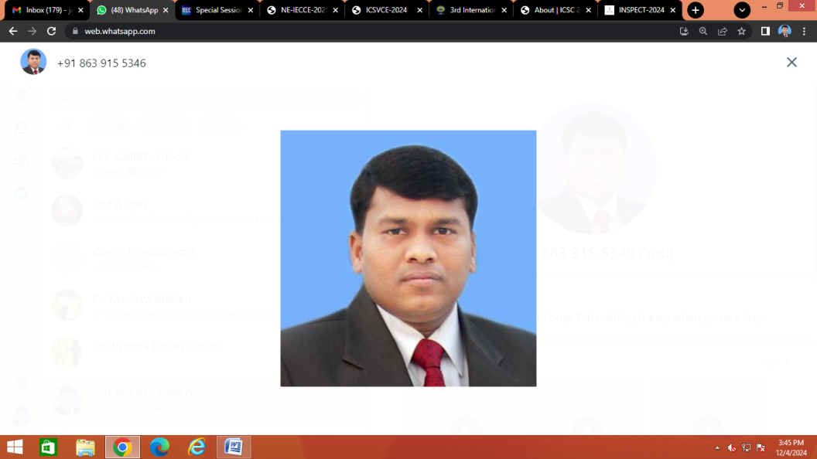
Dr. Jami Venkata Suman
Associate Professor, Department of ECE
GMR Institute of Technology, GMR Nagar, Rajam, Andhra Pradesh, India
Email: venkatasuman.j@gmrit.edu.in, jami.venkatasuman@gmail.com

Ph No: +91-8639155346

SESSION DESCRIPTION:
Artificial Intelligence (AI) and Machine Learning (ML), VLSI, Signal, Image and Video Processing have numerous applications in various engineering, science and medical applications, transforming the field in various ways:

VLSI Design Applications

- Logic Synthesis: AI-powered logic synthesis can optimize digital circuit designs for area, power, and performance.
- Physical Design: ML algorithms can be used to optimize physical design, including placement, routing, and timing closure.
- Fault Detection and Diagnosis: AI-powered systems can quickly identify and diagnose faults in VLSI designs, reducing debug time and costs.
- Power Optimization: ML algorithms can be used to optimize power consumption in VLSI designs, reducing heat dissipation and increasing battery life.
Embedded Systems Design Applications

- System-on-Chip (SoC) Design: AI-powered SoC design can optimize system architecture, reducing power consumption and increasing performance.
- Real-Time Operating System (RTOS) Optimization: ML algorithms can be used to optimize RTOS scheduling, reducing latency and increasing system responsiveness.
- Embedded Software Development: AI-powered tools can aid in embedded software development, including code generation, testing, and debugging.
- Predictive Maintenance: AI-powered predictive maintenance can be used to predict and prevent failures in embedded systems, reducing downtime and increasing overall efficiency.
Communication Engineering Applications

- Channel Estimation and Equalization: ML algorithms can improve channel estimation and equalization in wireless communication systems, enhancing data transmission rates and reliability.
- Resource Allocation: AI can optimize resource allocation in wireless networks, improving network efficiency, capacity, and user experience.
- Network Security: AI-powered systems can detect and prevent cyber threats in communication networks, ensuring secure data transmission.
- Signal Processing: ML algorithms can be applied to various signal processing tasks, such as filtering, modulation classification, and signal detection.

RECOMMENDED TOPICS:

- AI
- ML
- VLSI
- Signal, Image and Video Processing
- Embedded Systems
- IoT
- Integrated Networks

ORGANIZERS BIODATA:

Dr. Jami Venkata Suman received the degree in Electronics and Communication Engineering from Visvesvaraya Technological University, Karnataka, India, the Master of Technology degree in VLSI System Design from JNTUH, Andhra Pradesh, India, and the Ph.D. degree in Electronics and Communication Engineering from GITAM (Deemed to be University), Visakhapatnam, Andhra Pradesh. He is currently an Associate Professor with the Department of Electronics and Communication Engineering, GMR Institute of Technology, Rajam. He has been in the teaching profession for more than 17 years. He has published more than 100 papers in national and international journals, conferences, and symposiums. He has 14 patents published and 22 patents granted, and have eight books published. He has served as a technical reviewer, advisory board member and editorial board member in many reputed national and international journals and conferences. He is life member of ISTE and senior member of IEEE. His main research interests include Low Power VLSI Design, FPGA Implementation, VLSI Signal Processing, Digital IC Design and Embedded Systems.

