International Conference on Cyber Analytics and Information Retrieval

Organized by
Sister Nivedita University (SNU), India

Technically Sponsored by:
Scientific Innovation Research Group (SIRG), Egypt
Scientific Research Group in Egypt (SRGE), Egypt
CI2S lab, Argentina

Date: 24th – 25th April 2025 (Hybrid Mode)

************** CALL FOR PAPERS **************

SPECIAL SESSION

Recent trends on Blockchain, Cloud Computing, Machine Learning and Bigdata for real life problem-solving

SESSION ORGANIZERS:

 | 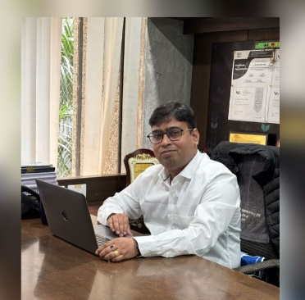
Dr. Bipin Kumar Rai  Professor(CSE)  Dayananda Sagar University, Bengaluru, India  bipinkrai@gmail.com | Dr. Sushil Kumar Singh  Associate Professor, Department of Computer Engineering  Marwadi University, Rajkot, Gujarat, India  sushilkumar.singh@marwadieducation.edu.in

SESSION DESCRIPTION:

Blockchain has significantly exhibited a huge potential to create trust and consensus structures without the intervention of any third party. Machine has contributed a lot in Artificial Intelligence leading to drastic automation in every industry. Big Data defines a broad range of vast data generated, processed and stored in different sector. Although these data share some common characteristics with conventional big data, they have their own unique characteristics and provide various advantages for academic research and realistic applications. Although good prospects can be anticipated, there are some challenges associated with the combination of cloud computing, Blockchain, Machine Learning and Bigdata for real life problem-solving.
The aim of this special session is to give an open platform for exchanging ideas and recent techniques among researchers.

RECOMMENDED TOPICS:

Topics to be discussed in this special session include (but are not limited to) the following:

• Blockchain and its applications for healthcare

• Blockchain with Internet of Things for supply chain

• Machine Learning for smart networks

• Bigdata in wireless networks

• Cloud Computing technologies and applications

• Internet based applications in cloud computing and Blockchain

• Cloud Computing for scientific applications

• Performance evaluation, modelling and prediction

• Applications of Bigdata, cloud computing, and Blockchain

• Blockchain for Medication Administration Records

• Ensuring Privacy and security of healthcare data using blockchain

PUBLICATION AND SUBMISSION PROCEDURE

The conference aims at carrying out double-blind review process. The papers submitted by the authors will be assessed based on their technical suitability, the scope of work, plagiarism, novelty, clarity, completeness, relevance, significance, and research contribution. The conference proceedings will be published in AIP Web of Science, Scopus series.

NOTE: While submitting the paper in this special session, please specify [Recent trends on Blockchain, Cloud Computing, Machine Learning and Bigdata for real life problem-solving] at the top (above paper title) of the first page of your paper.

* * * * * *

